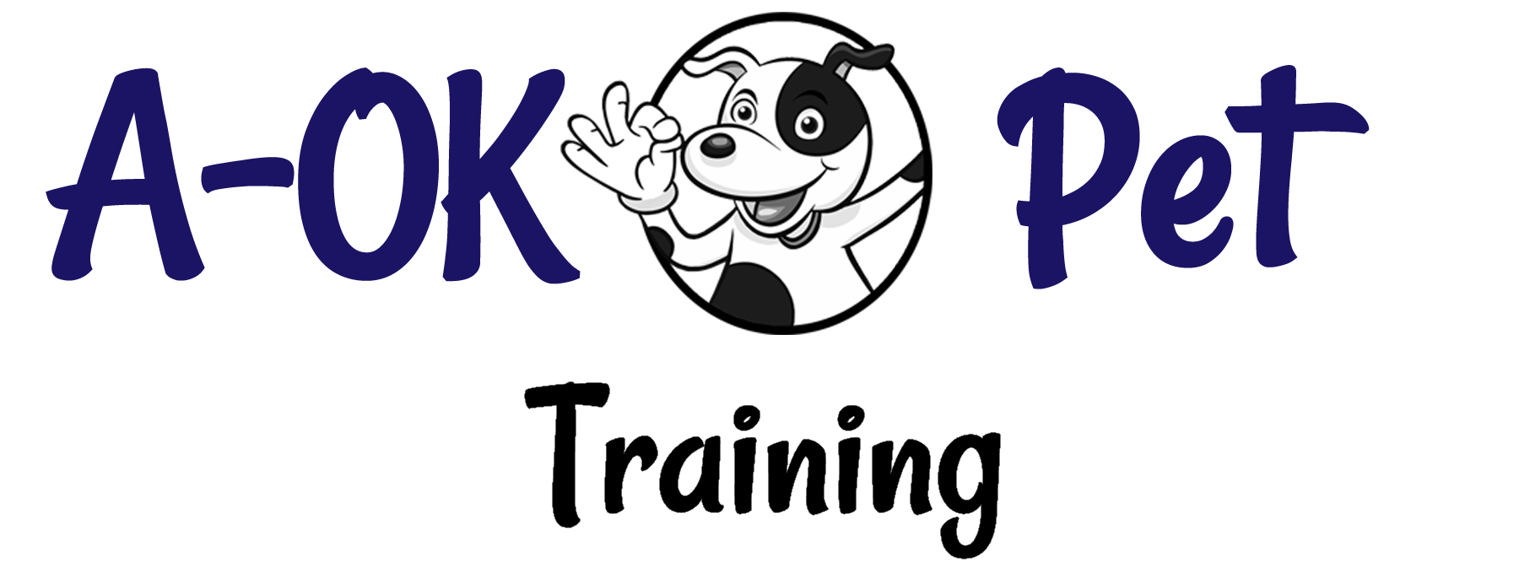

Basic Intake & Goal Assessment

Client & Cat Information

Guardian’s Name: | Date:
Home Phone: | Work Phone:
Cell Phone: | Email:
How did you hear about us?

Cat’s Name/ ID: | Breed/Age/Sex:
Date of Adoption: | Declawed: Front / Back Date:
Most recent vet visit and results:

Cat’s Routine

Describe your cat’s daily routine:

What does (Fluffy) do for exercise, and how often and for how long?

What does (Fluffy) do when you’re gone from the house?

What kinds of toys, chews, etc. does (Fluffy) play with, and how often? When does he/she play with his/her toys?

Training History/Reinforcers

Have you done any training with (Fluffy), or had he/she done any before you adopted him? Where did you do the training? Can you describe the basic approach you learned to train your cat? Did you feel you got the results you were looking for?

What are your cat’s favorite foods or treats?

What are your cat’s favorite toys:

What are your cat’s favorite activities?

Client’s Goals

What would you like your cat to do?

What would you like to be able to do with your cat?

